**LAB 5**

*Aryaman Patel*

Image Calibration –

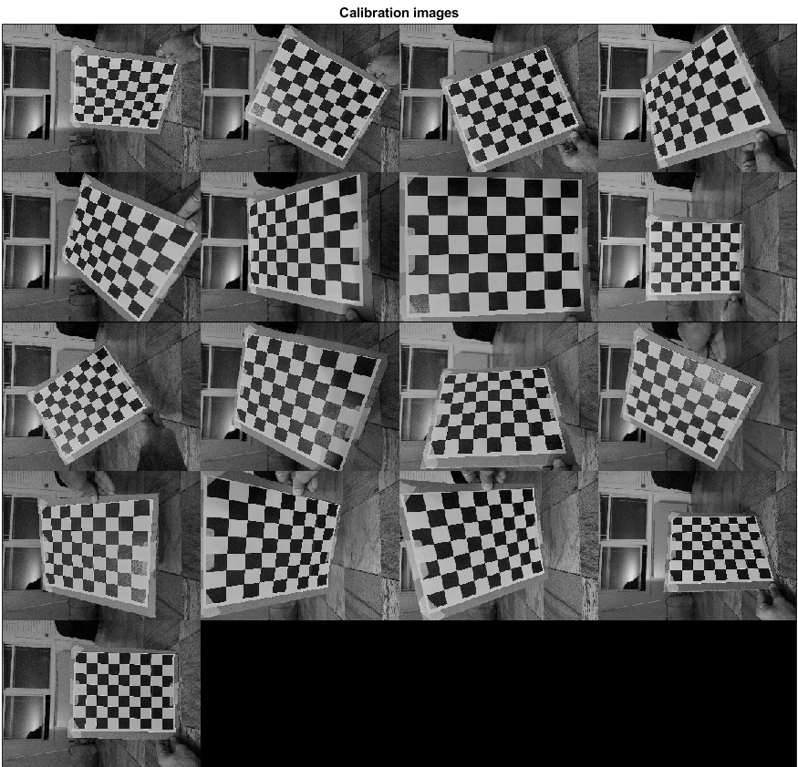

Figure: Images used in calibration.

Calibration results after optimization:

Focal Length: fc = [ 3358.00804 3358.39533 ] ± [ 10.72083 10.16836 ]

Principal point: cc = [ 2307.98481 1730.87525 ] ± [ 10.18953 8.66046 ]

Skew: alpha_c = [ 0.00000 ] ± [ 0.00000 ] => angle of pixel axes = 90.00000 ± 0.00000 degrees

Distortion: kc = [ 0.12992 -0.29378 -0.00133 0.00067 0.00000 ] ± [ 0.00868 0.02619 0.00101 0.00118 0.00000 ]

Pixel error: err = [ 1.34468 1.15063 ]

Reprojection error:

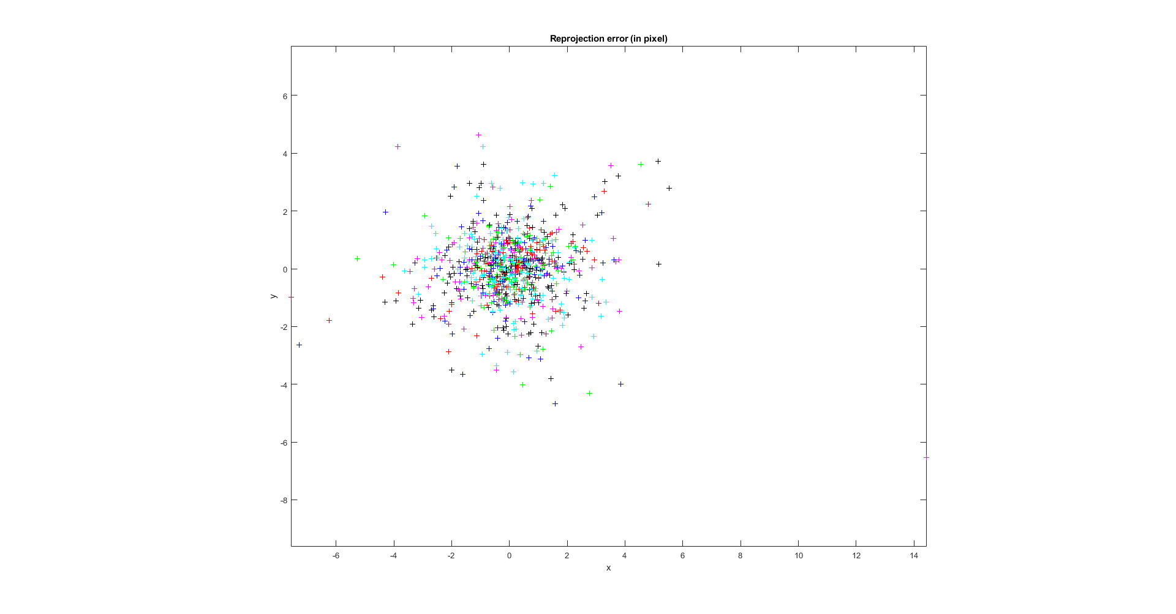

LSC Building Mural –

Figure: Collection of images clicked for the panorama after calibration.

%% Playing with the harris corner detection and convolve2

I = imrotate(readimage(buildingScene,1),270);

grayImage = im2gray(I);

%Harris corner detection:

harris(grayImage,500,'disp','tile',[3 3],'hsize',15,'sigma',7,'fft');

Figure: The Harris corner features

% Convolvolution applied to the images edge detection and sharpening

dx = [-1 -1 -1; -1 8 -1;-1 -1 -1]/100;

output = convolve2(grayImage,dx,'full');

imshow(output)

%Convolve2 with sharpening matrix

dx = [0 -1 0; -1 5 -1; 0 -1 0]/100;

output = convolve2(grayImage,dx,'same');

imshow(output)



Figure: The output of image convolution.

The image sharpening convolution applied gave better results in defining edges, hence I used these convolutions for the set of images in Harris corner detection algorithm.



Figure: Final Mosaic of the clicked images.

Brick Wall –

Figure: Brick Wall images.



Figure: Harris feature detection of the image.

Trying to run the panaroma code we get the following warning:

Warning: Maximum number of trials reached. Consider increasing the maximum distance or decreasing the desired confidence.

This error occurs as the confidence is set too high to find the maximum numbers of inliners to the matchedpoints.

By reducing the confidence we enable the feature matching between lesser features.

% Estimate the transformation between I(n) and I(n-1).

tforms(n) = estgeotform2d(matchedPoints, matchedPointsPrev,...

'projective', 'Confidence', 20, 'MaxNumTrials', 2000);

Decreasing the confidence of the estimates of the 2D geometric transformed points between the two images, we can get a mosaic of the images:



Figure: Brick wall mosaic attempt.

The resulting mosaic is incorrect as there are not many unique features in out images that result in lower confidence in out estimates of the inline function that tries to match the features. Hence, resulting in matching of incorrect feature points.

With 50% overlap –

Figure: Images for 50% overlap in points.

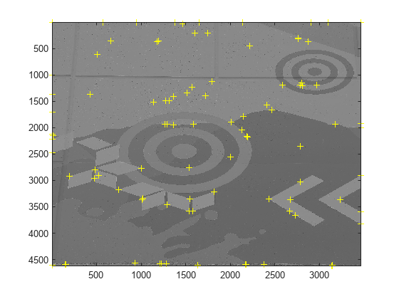

Figure: Harris feature detection on the image



Figure: Resulting Mural

Works only moderately better in places of partial features of in images with less significant feature detections. The results are better than 15% overlap.

With 15% overlap –

Figure: Images for 15% overlap



Figure: The Harris features on the images.



Figure: The resulting Mosiac.

The confidence of the estimate feature matching was reduced to 99% in order to generate a better mosaic.